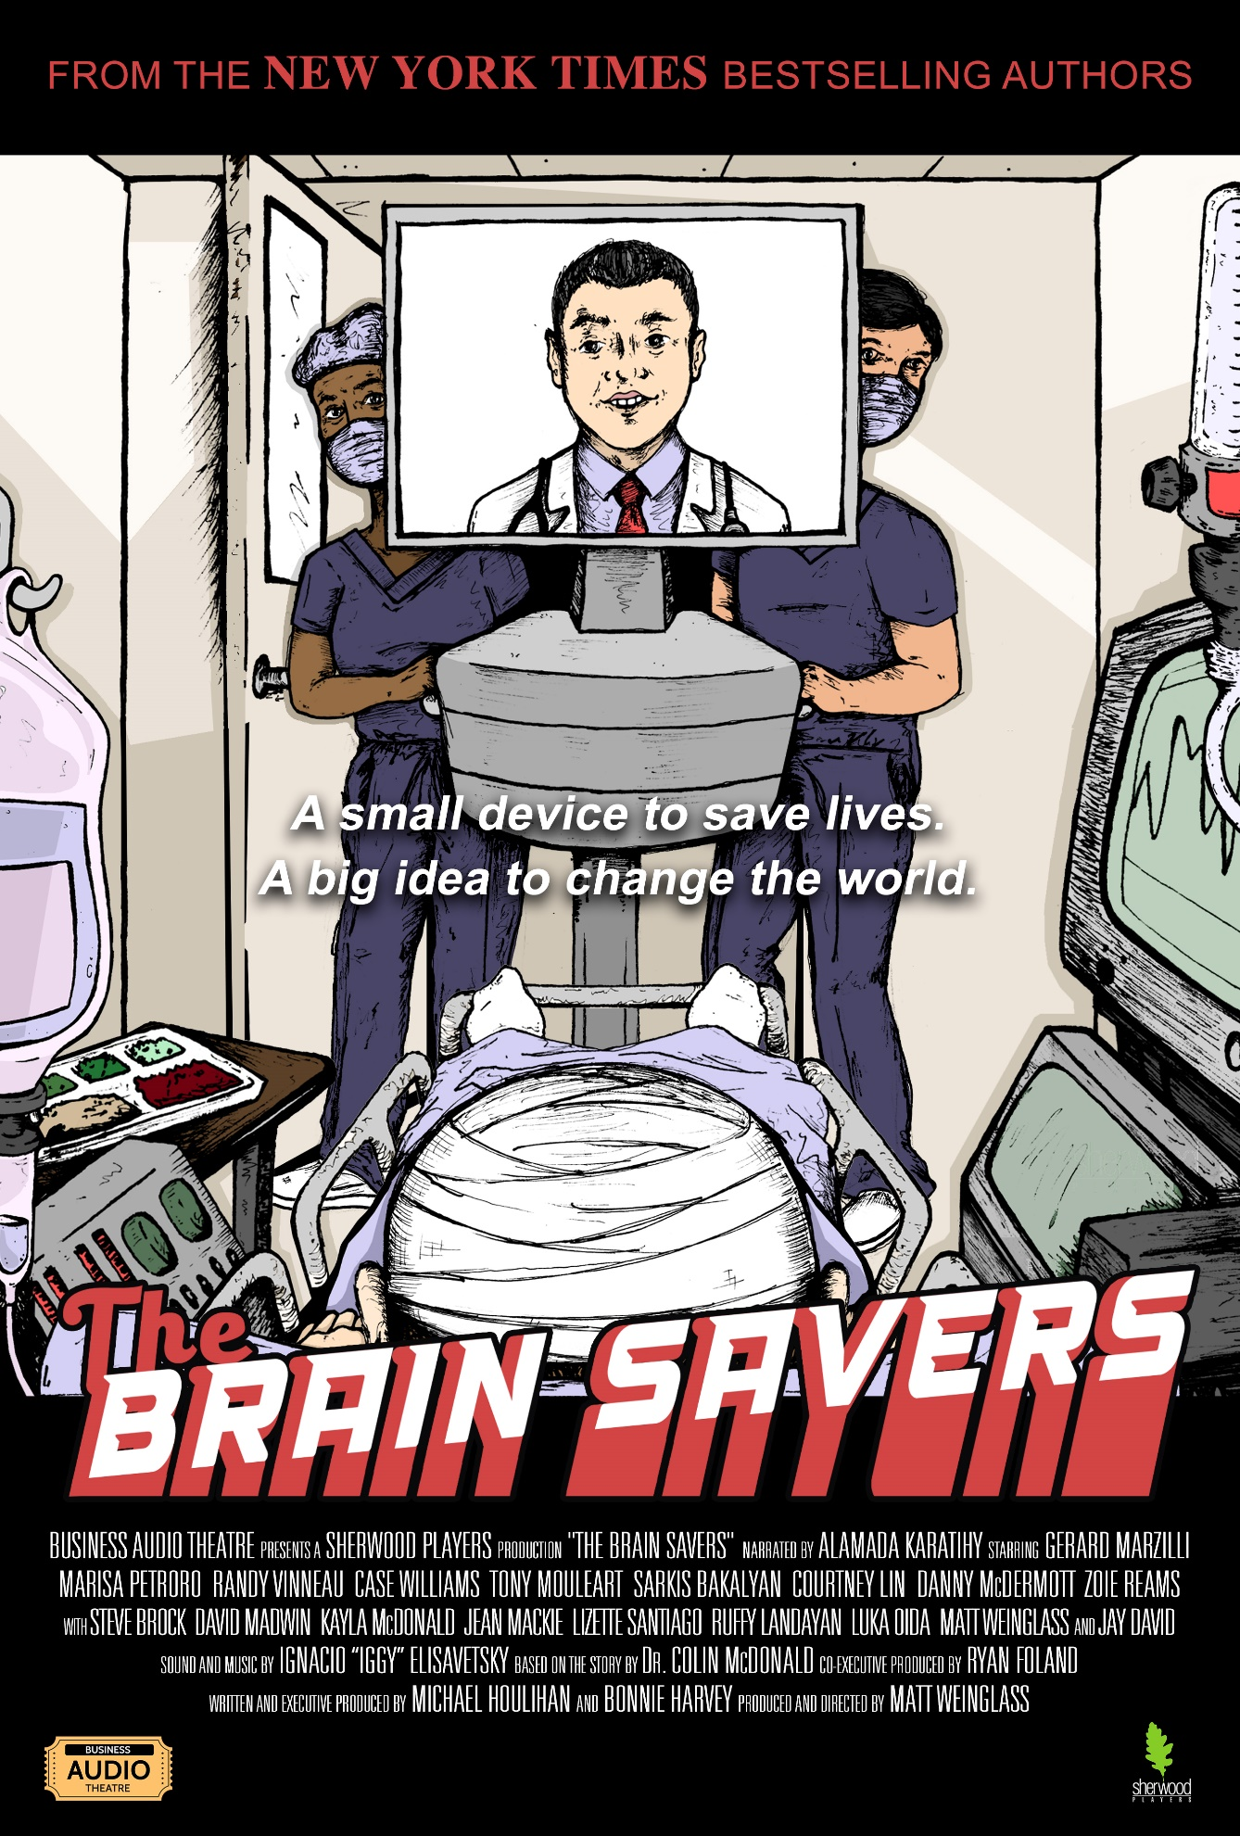
THE BRAIN SAVERS,
HOW A SCRAPPY STARTUP TRANSFORMED TELEMEDICINE AND PATIENT CARE

A FULL CAST PERFORMANCE, FEATURING HOLLYWOOD ACTORS, SOUND EFFECTS, AND AN ORIGINAL SCORE!

From the authors of the New York Times bestseller, The Barefoot Spirit, and the Audie Award finalist, genre-bending audiobook of the same name, comes a story of vision and invention, failure and setbacks, mistakes and lessons. Business Audio Theatre presents a Sherwood Players Production, The Brain Savers, the true story of how a scrappy startup used technology to put the humanity of patients first and ended up changing medicine forever.

Amid the internet boom of the mid-2000s, a band of entrepreneurs stood at the intersection of medicine, technology, and business. They saw a solution to the crucial problems of emergency care, which was too often handicapped by underfunding, overscheduled specialists, archaic practices, and onerous equipment. Through pioneering telemedicine and new inventions like the portable CT scanner, the founders of Specialists on Call (S.O.C.) did more than just make emergency care better, faster, and more humane; they brought health care, which is often described as the slowest industry in America to change, into the 21st Century.

This is Dr. Colin McDonald’s story of how S.O.C. came to be. After leaving a cushy teaching position at Harvard, it took years of pursuing a single objective, then changing on a dime, to create S.O.C. In the end, what he created was a system that saved lives—and continues to save lives today.

Some of these hard-learned lessons are complex, while others are so timeless they almost sound cliché (“trust your vision and your moral compass, change when you must, just keep going”), but they are far from cliché for the founders of S.O.C. Theirs is a story of people with imagination and drive who wanted to make the world better, who trusted their ideas and each other, and who, despite everything, kept on going!

