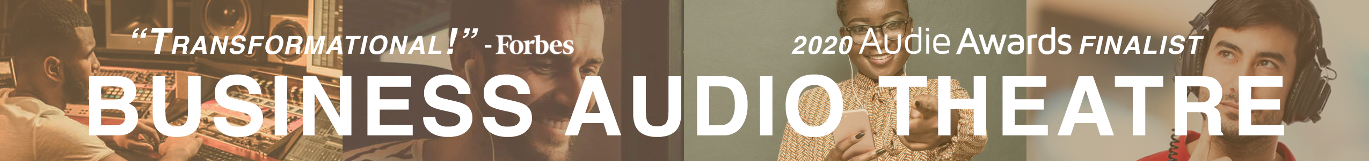

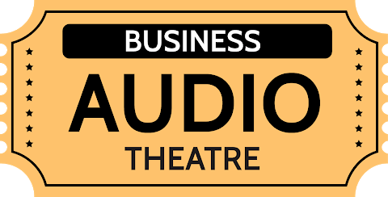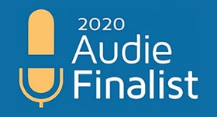

DO YOU WANT TO ATTRACT, RETAIN, AND ENGAGE
EMPLOYEES AND OTHER STAKEHOLDERS?

Tell them your story
in today’s preferred learning format!
Story is the most effective form to communicate your message – because story is memorable! Presenting your story in an audible format allows the listener to hear it when and where they want!

Bring your story to life,
1940’s radio theatre style!
Business Audio Theatre is performed, not simply narrated. Your business principles are dramatized through story using experienced actors voicing parts in seminal scenes that demonstrate your history and principles, complete with, sound effects and original musical score.
Your people will appreciate
what it took to build your business!
Witnessing the drama of your startup days, listeners identify with your humanity, vulnerability, and guiding principles. As they experience your challenges, they pull for you to achieve success, and become more engaged, loyal, and productive.

You won’t always be there!
Safeguard your legacy and company’s story for generations. Attract candidates who appreciate your journey. Reduce turnover when your people identify with your story, goals, and principles.

HEAR THE DIFFERENCE!

Strict narration vs Business Audio Theatre—Demo
Business Audio Theatre—Sample

Trust your story to the best!

Bonnie Harvey and Michael Houlihan are the Founders of Barefoot Wines and New York Times bestselling authors. The Barefoot Spirit, How Hardship, Hustle, and Heart Built America’s #1 Wine Brand, was the Audiobook Publishers Association’s Audie Finalist for the 2020 Business Audio Book of The Year.

Our latest Business Audio Theatre, The Brain Savers, How a Scrappy Startup Transformed Telemedicine and Patient Care performs the story of Dr. Colin T. McDonald, the Founder of Specialists on Call.

We know business. We have spoken at over 60 schools that teach entrepreneurship, keynoted at over 100 national and international business conferences, and written for Entrepreneur, The Business Journals, Forbes, and numerous other business publications. Our Hollywood partner, Sherwood Players Productions, is an award-winning film and audio production company with top actors, musicians, and sound engineers.

We have the writing and audio production credentials, business experience, and empathy to deliver the Business Audio Theatre that will be the most effective and you will be proud to share!

www.businessaudiotheatre.com 707 484 1600 michael@thebarefootspirit.com

